Lambda function AWS2ZabbixAlertMgmt Installation Guide

Client logo

Tooling & Automation

Partner logo

Contents

1. Introduction 3

2. Solution description 4

3. General information 4

4. Used services 4

5. Ouput data 5

6. Deploy process 6

6.1. Setup communication to AWS account 6

6.2. Adjusts Terraform variables values 6

6.3. Apply the configuration 8

6.4. Validate the communication 8

# Introduction

This document explains how to install lambda function AWS2ZabbixAlertMgmt.

# Solution description

Deploy all components to send CloudWatch alams to Zabbix.

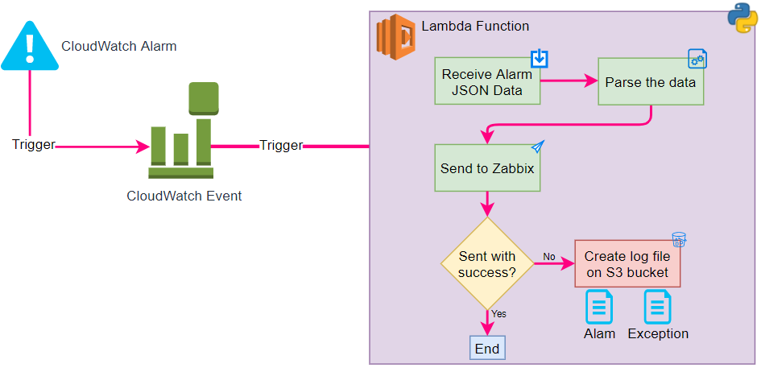

The terraform code is available in aws2zabbixalertmgmt.zip archive.

# General information

This solution will only send the Alarm, that means, the alarms must exist on CloudWatch.

How all communication must be done safely, the Lambda function is deployed in some VPC to be able to communicate through a VPN, VPN peering or other safe way.

# Used services

* Lambda function
* IAM Role and Policy
* Simple Storage Service (S3)
* CloudWatch Alarm
* CloudWatch Event
* Custom security groups

# Ouput data

This function will send the data to Zabbix with the structure below :

Where :

|  |  |  |
| --- | --- | --- |
| Field | Description | Example |
| ElementID | AWS element ID | NLB: app/webnlb/2ac70ee809beef39  EC2 Instance: i-0be4f944b1cb43788 |
| MetricName | Metric Name on CloudWatch | RequestCount, CPUUtilization |
| AlertMessage + threshold | Message that generated the alert | was not greater than or equal to the threshold (Threshold Value) |
| AlertValue | Alert value rounded to 2 decimal places | 10 or 10.2 |
| AlertStatus | Status from CloudWatch | OK, ALARM or INSUFFICIENT_DATA |
| AlertOldStatus | Previous Status from CloudWatch | OK, ALARM or INSUFFICIENT_DATA |
| ResourceType | Kind of AWS Resource | **NLB:** AWS/ApplicationELB **EC2 Instance:** AWS/EC2 |
| AWS Region | Resource Region | eu-west-3 |

Example for a Load Balancer alarm:



# Deploy process

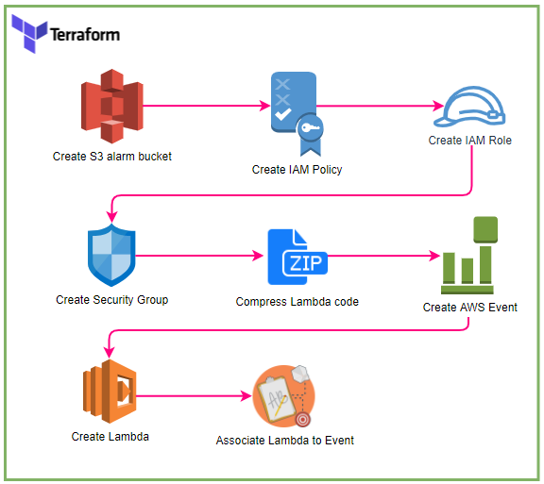

## Setup communication to AWS account

Configure the credentials to communicate to AWS.

This step depending of the customer CI/CD solution, on Azure DevOps this step can be done adding a Service Connection in the project.

## Adjusts Terraform variables values

All variables must be changed on Terraform variable file (terraform.tfvars).

They were divided into groups:

**General** (General data that may be used for others scripts)

|  |  |  |  |
| --- | --- | --- | --- |
| Variable | Type | Description | Default |
| region | string | AWS region | eu-west-3 |
| env | string | Environment of the solution | prd |
| app | string | Application name | Inetum Monitoring |

**lambdaAlerts** (These variables are specific for AWS Lambda function)

| Variable | Type | Description | Default |
| --- | --- | --- | --- |
| name | string | Name of Lambda function | Inetum_SendCloudWatchToZabbix |
| description | string | Description of Lambda function | Function to send alerts from CloudWatch to Zabbix |
| s3BucketName | string | S3 bucket name to save the error logs | inetum |
| s3FilePath | string | Path to save the error log files in S3 bucket | AlarmsNotSent |
| vpcId | string | VPC ID to deploy the Lambda function | NULL |
| subnetIds | array | Subnets ID to deploy the Lambda function | NULL |
| logRetention | number | Retention of CloudWatch Lambda execution (days) | 30 |
| timeout | number | Timeout to execute Lambda function | 10 |

**zabbix (Information about Zabbix connection to be used in Python script on Lambda function)**

| **Variable** | **Type** | **Description** | **Default** |
| --- | --- | --- | --- |
| host | string | The IP Address or FQDN of the Zabbix Proxy (Proxy must be reacheable from the account automation) | NULL |
| port | Integer | TCP port used by Zabbix proxy to listen incoming alerts | 10052 |
| clientName | string | Client Name define to Zabbix from where the alert will come from | NULL |
| trapItem | string | Name of item on Zabbix configured to receive these alerts | awsalert |
| timeout | number | timeout to connect to Zabbix server | 5 |

By default, the TF code will apply some TAGs, if necessary you can change the alarm_tags object in variables.tf file

## Apply the configuration

This step depending the customer CI/CD solution.

In Azure DevOps you might need to run a Pipeline and/or a Release.

In terraform CLI you might need to run the command *terraform apply*.

## Validate the communication

Check if the target group is health, after that, ask to Inetum Tooling team to validate the communication to base infrastructure.

You might force an alarm trigger and check the Lambda function execution log and on Zabbix server.

### Révisions

|  |  |  |
| --- | --- | --- |
| Version | Date | Objet |
| 1.0 | 27/09/2021 | Création of document |
|  |  |  |
|  |  |  |

### Visas

|  |  |  |  |
| --- | --- | --- | --- |
|  | Responsable | Date | Visas |
| Rédaction | Sophie Dupont | 27/09/2021 | SDU |
| Vérification |  |  |  |
| Approbation |  |  |  |

### Diffusion

|  |  |
| --- | --- |
| Entreprise | Destinataire |
| INETUM | Skill Center IS |
|  |  |
|  |  |